BANK LOAN REPORT SUMMARY

KPIs:

Total Loan Application

select count(id) as 'Total Loan Application' from bank_loan_data;

Month to Date Total Loan Application

select count(id) as 'MTD Total Loan Application' from bank_loan_data

where month(issue_date) = 12 and year(issue_date) = 2021;

Previous Month to Date Total Loan Application

select count(id) as 'PMTD Total Loan Application' from bank_loan_data

where month(issue_date) = 11 and year(issue_date) = 2021;



Total Funded Amount

select sum(loan_amount) as "Total Funded Amount" from bank_loan_data;

Month to Date Total Funded Amount

select sum(loan_amount) as "MTD Total Funded Amount" from bank_loan_data

where month(issue_date) = 12 and year(issue_date) = 2021;

Previous Month to Date Total Funded Amount

select sum(loan_amount) as "PMTD Total Funded Amount" from bank_loan_data

where month(issue_date) = 11 and year(issue_date) = 2021;



Total Amount Received

select sum(total_payment) as "MTD Total Amount Recived" from bank_loan_data;

Month to Date Total Amount Received

select sum(total_payment) as "MTD Total Amount Recived" from bank_loan_data

where month(issue_date) = 12 and year(issue_date) = 2021;

Previous Month to Date Total Amount Received

select sum(total_payment) as "PMTD Total Amount Recived" from bank_loan_data

where month(issue_date) = 11 and year(issue_date) = 2021;



Average Interest Rate

select ROUND(avg(int_rate) * 100,2) as "Average Intrest Rate" from bank_loan_data;

Month to Date Average Interest Rate

select round(AVG(int_rate) * 100,2) as "Average Intrest Rate" from bank_loan_data

where month(issue_date) = 12 and year(issue_date) = 2021;

Previous Month to Date Total Amount Received

select round(AVG(int_rate) * 100,2) as "Average Intrest Rate" from bank_loan_data

where month(issue_date) = 11 and year(issue_date) = 2021;



Debt To Income Ratio

Average Debt To Income Ratio

select round(AVG(dti) * 100,2) as "Average Debt To Income Ratio" from bank_loan_data;

Month to Date Debt To Income Ratio

select round(AVG(dti) * 100,2) as "MTD Average Debt To Income Ratio" from bank_loan_data

where month(issue_date) = 12 and year(issue_date) = 2021;

Previous Month to Date Debt To Income Ratio

select round(AVG(dti) * 100,2) as "MTD Average Debt To Income Ratio" from bank_loan_data

where month(issue_date) = 11 and year(issue_date) = 2021;



GOOD LOAN APPLICATION PERCENTAGE

select

round((count(case when loan_status = 'Fully Paid' OR loan_status = 'Current' then id end) * 100)

/

count(id) ,2) as "Good Loan Percentage"

FROM bank_loan_data;



GOOD LOAN APPLICATION

SELECT COUNT(id) as "Good Loan Application" from bank_loan_data where loan_status = 'Fully Paid' OR loan_status = 'Current';

GOOD LOAN FUNDED AMOUNT

SELECT SUM(loan_amount) as "Good Loan Funded Amount" from bank_loan_data

where loan_status = 'Fully Paid' or loan_status = 'Current';

GOOD LOAN TOTAL RECIVED AMOUNT

SELECT SUM(total_payment) as "Good Loan Total Recived Amount" from bank_loan_data

where loan_status = 'Fully Paid' or loan_status = 'Current';



BAD LOAN ISSUED

Bad Loan Percentage

select

round((count(case when loan_status = 'Charged Off' then id end) * 100)

/

count(id) ,2) as "Bad Loan Percentage"

FROM bank_loan_data;

BAD LOAN APPLICATION

SELECT COUNT(id) as "Bad Loan Application" from bank_loan_data

where loan_status = 'Charged Off';

BAD LOAN FUNDED AMOUNT

SELECT SUM(LOAN_AMOUNT) as "Bad Loan Funded Amount" from bank_loan_data

where loan_status = 'Charged Off';

BAD LOAN TOTAL RECIVED AMOUNT

SELECT SUM(total_payment) as "Bad Loan Total Recived Amount" from bank_loan_data

where loan_status = 'Charged Off';



LOAN STATUS GRID VIEW

SELECT

loan_status,

count(id) AS "Loan Count",

SUM(total_payment) AS "Total Payment Recived",

SUM(loan_amount) AS "Total Funded Amount",

AVG(int_rate * 100) AS "Intrest Rate",

AVG(dti * 100) AS DTI

FROM bank_loan_data

GROUP BY loan_status;

LOAN STATUS MONTH TO DATE GRID VIEW

SELECT

loan_status,

sum(total_payment) AS "MTD Total Payment Recived",

sum(loan_amount) AS "MTD Total Funded Amount"

from bank_loan_data

where month(issue_date) = 12

GROUP BY loan_status;



MONTHLY TREND ISSUE DATE

SELECT

MONTH (issue_date) AS "Month Number",

MONTHNAME(issue_date) AS "Month NAme",

count(id) AS "Total Loan Application",

sum(loan_amount) AS "Total_Funded Amount",

SUM(total_payment) as "Total Recived Amount"

FROM bank_loan_data

GROUP BY MONTH (issue_date), MONTHNAME(issue_date)

ORDER BY MONTH (issue_date);

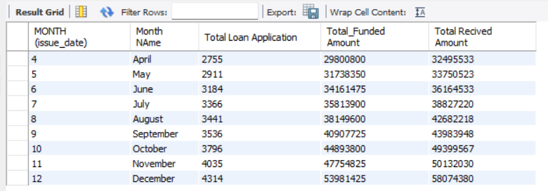



REGIONAL ANALYSIS BY STATE

SELECT

address_state,

count(id) AS "Total Loan Application",

sum(loan_amount) AS "Total_Funded Amount",

SUM(total_payment) as "Total Recived Amount"

FROM bank_loan_data

GROUP BY address_state

ORDER BY address_state;

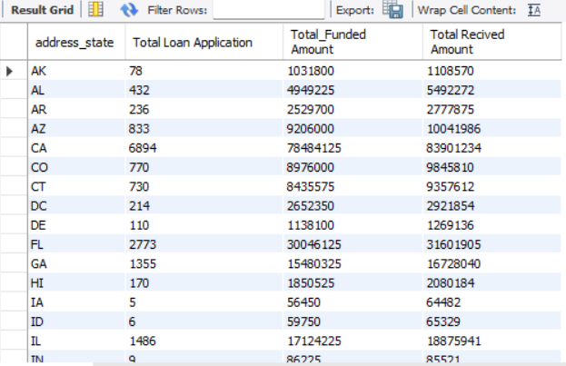



LOAN TERM ANALYSIS

SELECT

term,

count(id) AS "Total Loan Application",

sum(loan_amount) AS "Total_Funded Amount",

SUM(total_payment) as "Total Recived Amount"

FROM bank_loan_data

GROUP BY term

ORDER BY term;

EMPLOYEE LENGTH ANALYSIS



SELECT

emp_length,

count(id) AS "Total Loan Application",

sum(loan_amount) AS "Total_Funded Amount",

SUM(total_payment) as "Total Recived Amount"

FROM bank_loan_data

GROUP BY emp_length

ORDER BY COUNT(id);

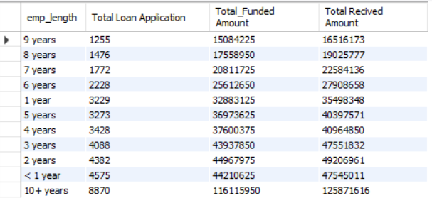



PURPOSE OF THE LOAN

SELECT

purpose,

count(id) AS "Total Loan Application",

sum(loan_amount) AS "Total_Funded Amount",

SUM(total_payment) as "Total Recived Amount"

FROM bank_loan_data

GROUP BY purpose

ORDER BY count(id);

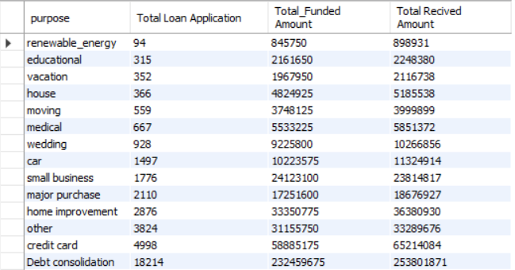



HOME OWNERSHIP

SELECT

home_ownership,

count(id) AS "Total Loan Application",

sum(loan_amount) AS "Total_Funded Amount",

SUM(total_payment) as "Total Recived Amount"

FROM bank_loan_data

GROUP BY home_ownership

ORDER BY count(id);

